Microprocessor and Computer Architecture
UE24CS251B
4th Semester, Academic Year 2025-26
Date:
Name: Harshit Chandak | SRN:  PES2UG24CS185 | Section  C

LAB #____4_______ Program Number: ____1___
Title of the Program
Write an ALP to perform Convolution using MLA instruction (Addition of multiplication of respective numbers of loc A and loc B).
- Typed ARM Assembly Code
- Output Screen Shot
( Screenshot including Register Window,Output Window and Code Window)
.DATA
A: .WORD 10,20,30,40,50
B: .WORD 10,20,30,40,50

.TEXT

LDR R0,=A
LDR R1,=B
MOV R2,#0
MOV R5,#0

LOOP:
LDR R3,[R0],#4
LDR R4,[R1],#4
MLA R5,R3,R4,R5
ADD R2,R2,#1
CMP R2,#5
BNE LOOP

SWI 0x11

.END

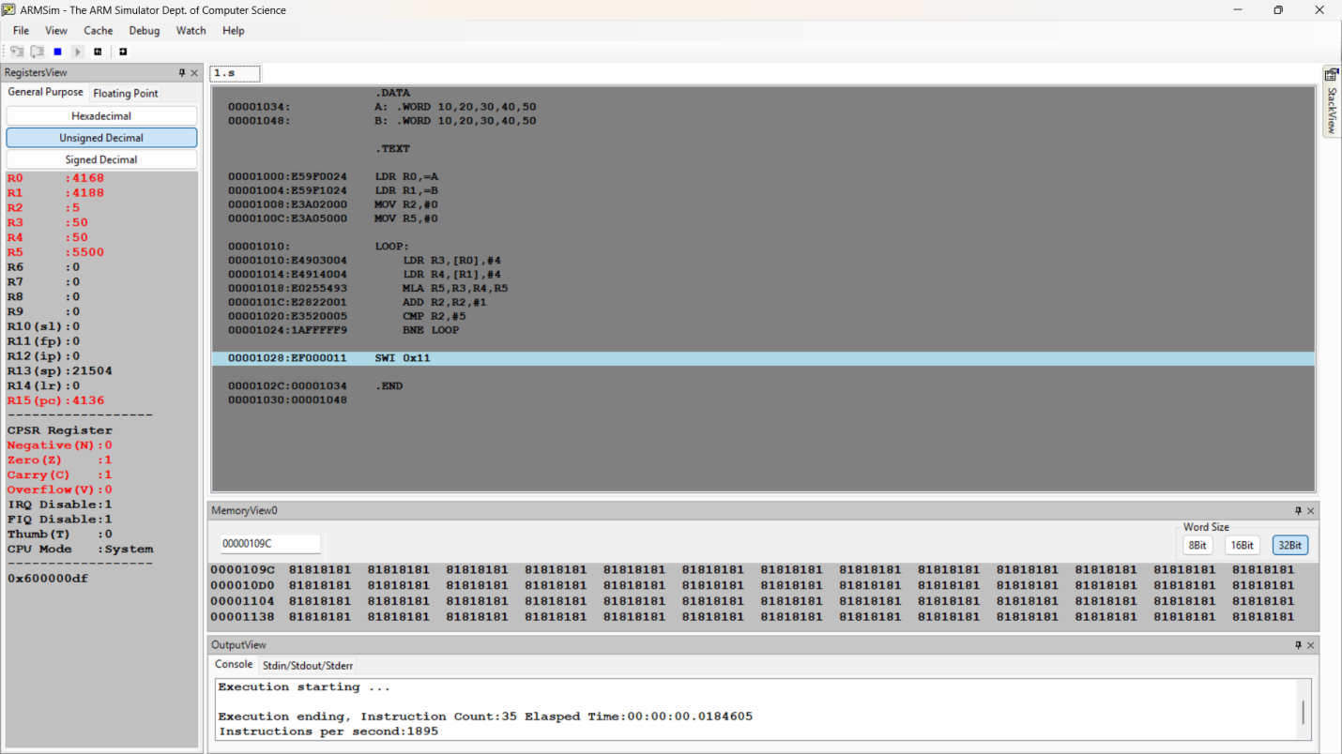
Microprocessor and Computer Architecture
UE24CS251B
4th Semester, Academic Year 2025-26
Date:
Name: Harshit Chandak | SRN:  PES2UG24CS185 | Section  C

LAB #____4_______ Program Number: ____2___
Title of the Program
Write a program in ARM7TDMI-ISA to generate a diagonal matrix.
; Note: do not read the matrix elements.
Let the Diagonal Value be 2
- Typed ARM Assembly Code
- Output Screen Shot

(One Screenshot including Register Window,Output Window and Code Window,Memory Window)

.DATA
A: .WORD 0,0,0,0,0,0,0,0,0

.TEXT

MOV R0,#2
MOV R1,#0
LDR R2,=A

LOOP:
STR R0,[R2],#16
ADD R1,R1,#1
CMP R1,#3
BNE LOOP

SWI 0x11

.END

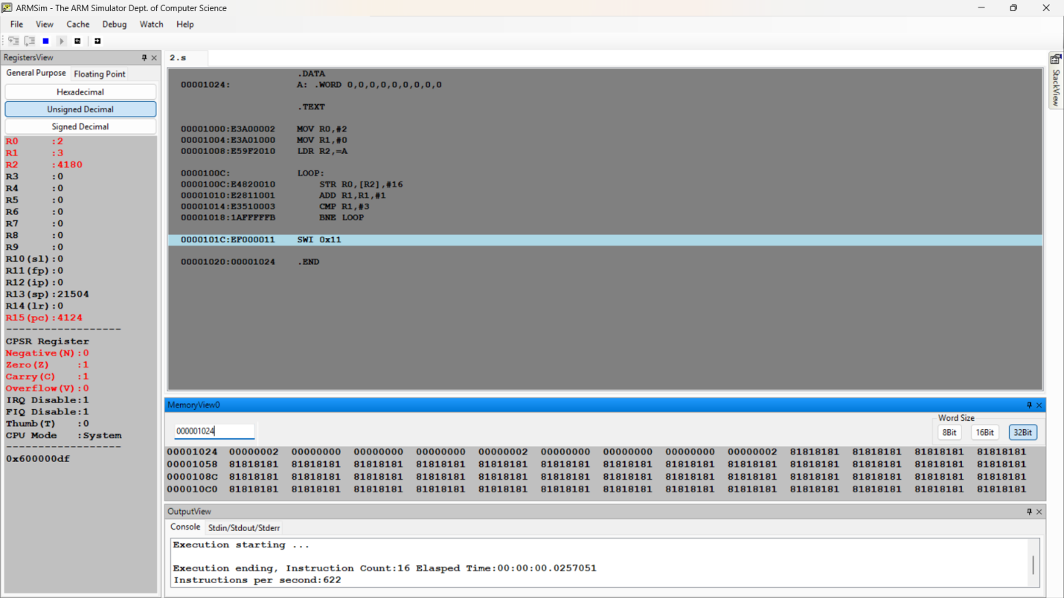

Microprocessor and Computer Architecture
UE24CS251B
4th Semester, Academic Year 2025-26
Date:
Name: Harshit Chandak | SRN:  PES2UG24CS185 | Section  C

LAB #____4_______ Program Number: ____3___
Title of the Program
Write a program in ARM7TDMI-ISA to transfer a block of 16 words stored at memory location X to memory location Y using Load Multiple and Store Multiple instructions. The rate of transfer is 24 bytes
- ARM Assembly Code
- Output Screen Shot
(One Screenshot including Register Window,Memory Window and Code Window)
.DATA
A: .WORD 1,2,3,4,5,6,7,8,9,10,11,12,13,14,15,16
B: .WORD 0,0,0,0,0,0,0,0,0,0,0,0,0,0,0,0,0,0,0

.TEXT

MOV R0,#16
MOV R1,#0
LDR R3,=A
LDR R4,=B

LOOP:
MOV R2,#0

INNERLOOP:
LDR R5,[R3],#4
STR R5,[R4],#4
SUB R0,R0,#1
ADD R2,R2,#1
CMP R2,#6
BNE INNERLOOP

ADD R1,R1,#1
CMP R1,#2
BNE LOOP

REMAINING:
LDR R5,[R3],#4
STR R5,[R4],#4
SUB R0,R0,#1
CMP R0,#0
BNE REMAINING
BEQ EXIT
EXIT:
SWI 0x11

.END

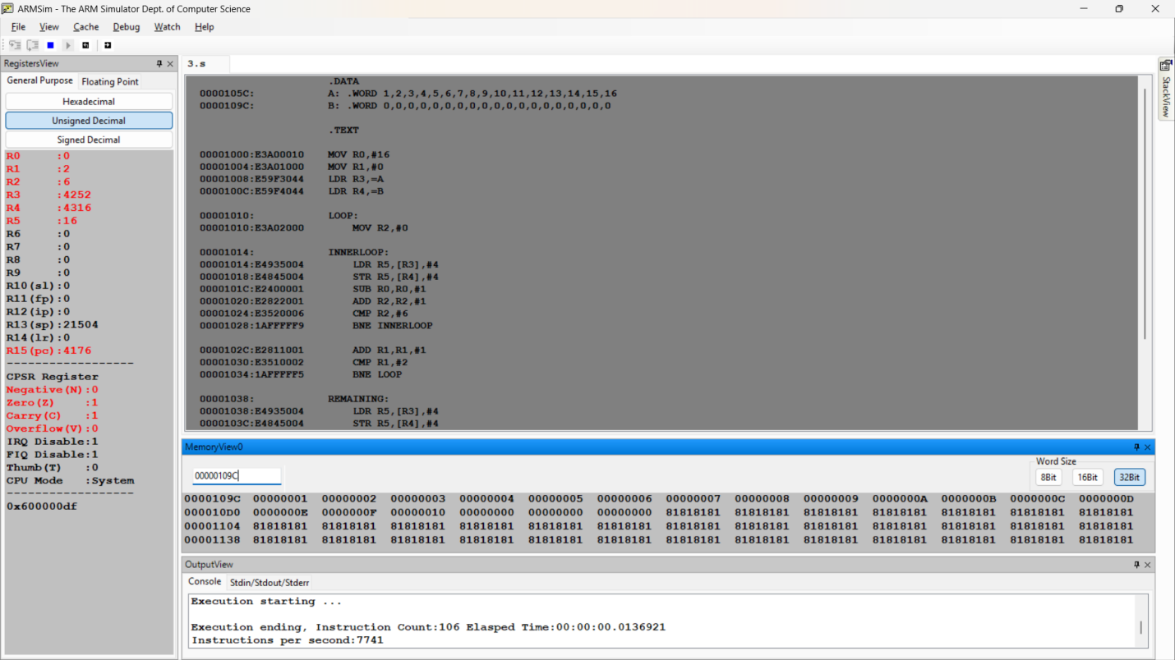

2 ND WAY
.DATA
A: .WORD 1, 2, 3, 4, 5, 6, 7, 8, 9, 10, 11, 12, 13, 14, 15, 16
B: .WORD 0, 0, 0, 0, 0, 0, 0, 0, 0, 0, 0, 0, 0, 0, 0, 0

.TEXT
LDR R0, =A
LDR R1, =B
MOV R2, #16

LOOP:
LDMIA R0!, {R3-R8}
STMIA R1!, {R3-R8}
SUB R2, R2, #6
CMP R2, #6
BLT REMAINDER
B LOOP

REMAINDER:
CMP R2, #0
BEQ EXIT
LDMIA R0!, {R3}
STMIA R1!, {R3}
SUB R2, R2, #1
B REMAINDER

EXIT:
SWI 0X11

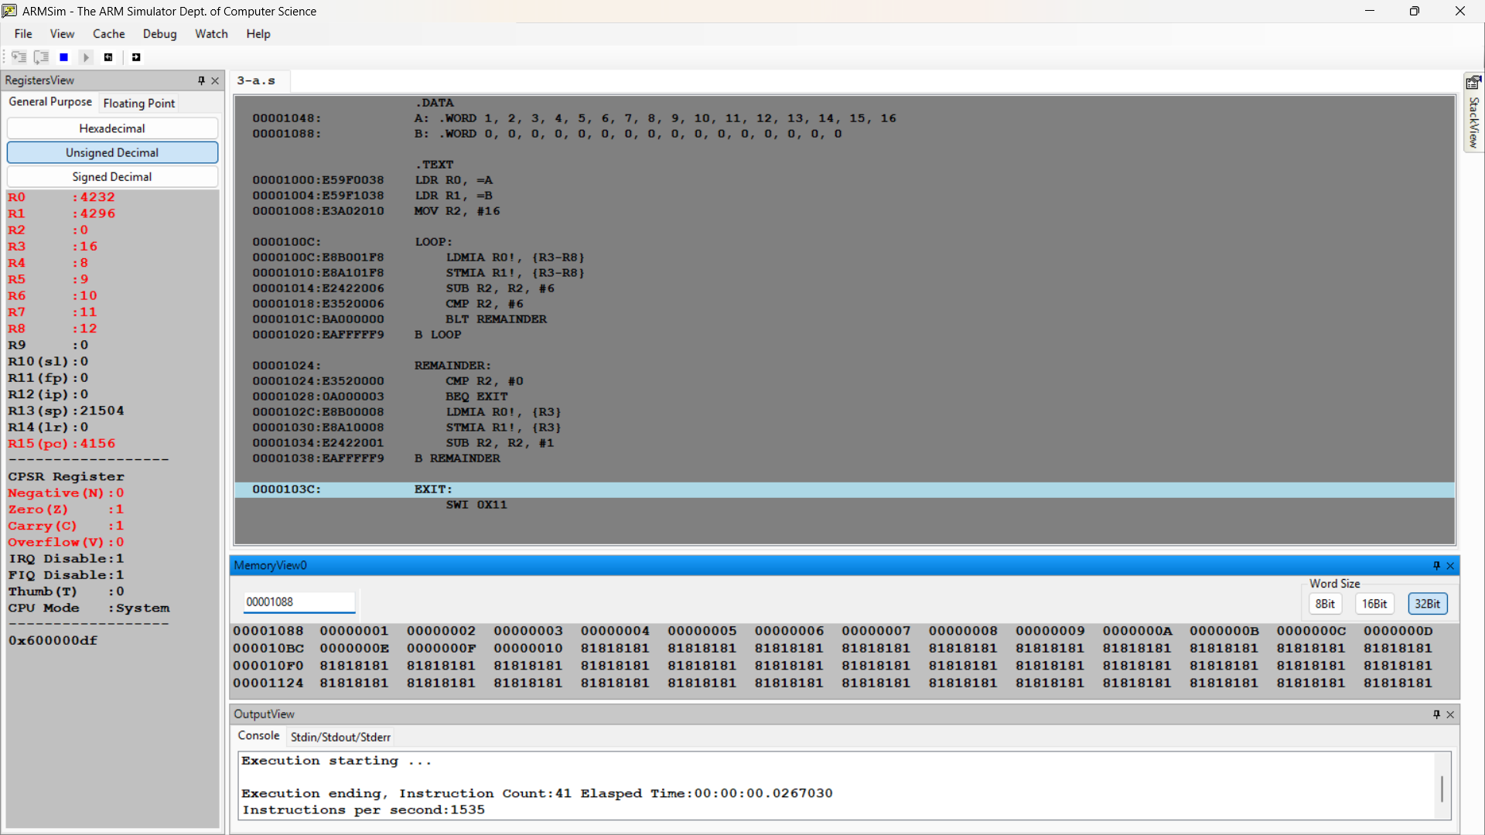

Microprocessor and Computer Architecture
UE22CS251B
4th Semester, Academic Year 2023-24
Date:
Name:Harshit Chandak | SRN:PES2UG24CS185 | Section  C

LAB #____4_______ Program Number: ____4___
Title of the Program
Write an ARM ALP to perform element-wise addition of two 3×3 matrices using indexed addressing and nested loops.
Requirements
- Matrices A and B each contain 9 elements (3 rows × 3 columns)
- Matrix C should store the sum of corresponding elements
- Use nested loops to traverse rows and columns
- Use the MLA (Multiply Accumulate) instruction to compute the memory offset
- Each matrix element is a 32-bit word

- ARM Assembly Code
- Output Screen Shot
(One Screenshot including Register Window,Memory Window and Code Window)

.DATA
A: .WORD 1,2,3,4,5,6,7,8,9
B: .WORD 1,2,3,4,5,6,7,8,9
C: .WORD 0,0,0,0,0,0,0,0,0

.TEXT

LDR R0,=A
LDR R1,=B
LDR R2,=C

MOV R5,#0
MOV R7,#1

LOOP:
LDR R3,[R0]
LDR R4,[R1]
MLA R6,R3,R7,R4
STR R6,[R2]

ADD R0,R0,#4
ADD R1,R1,#4
ADD R2,R2,#4

ADD R5,R5,#1
CMP R5,#9

BNE LOOP

SWI 0x11

.END

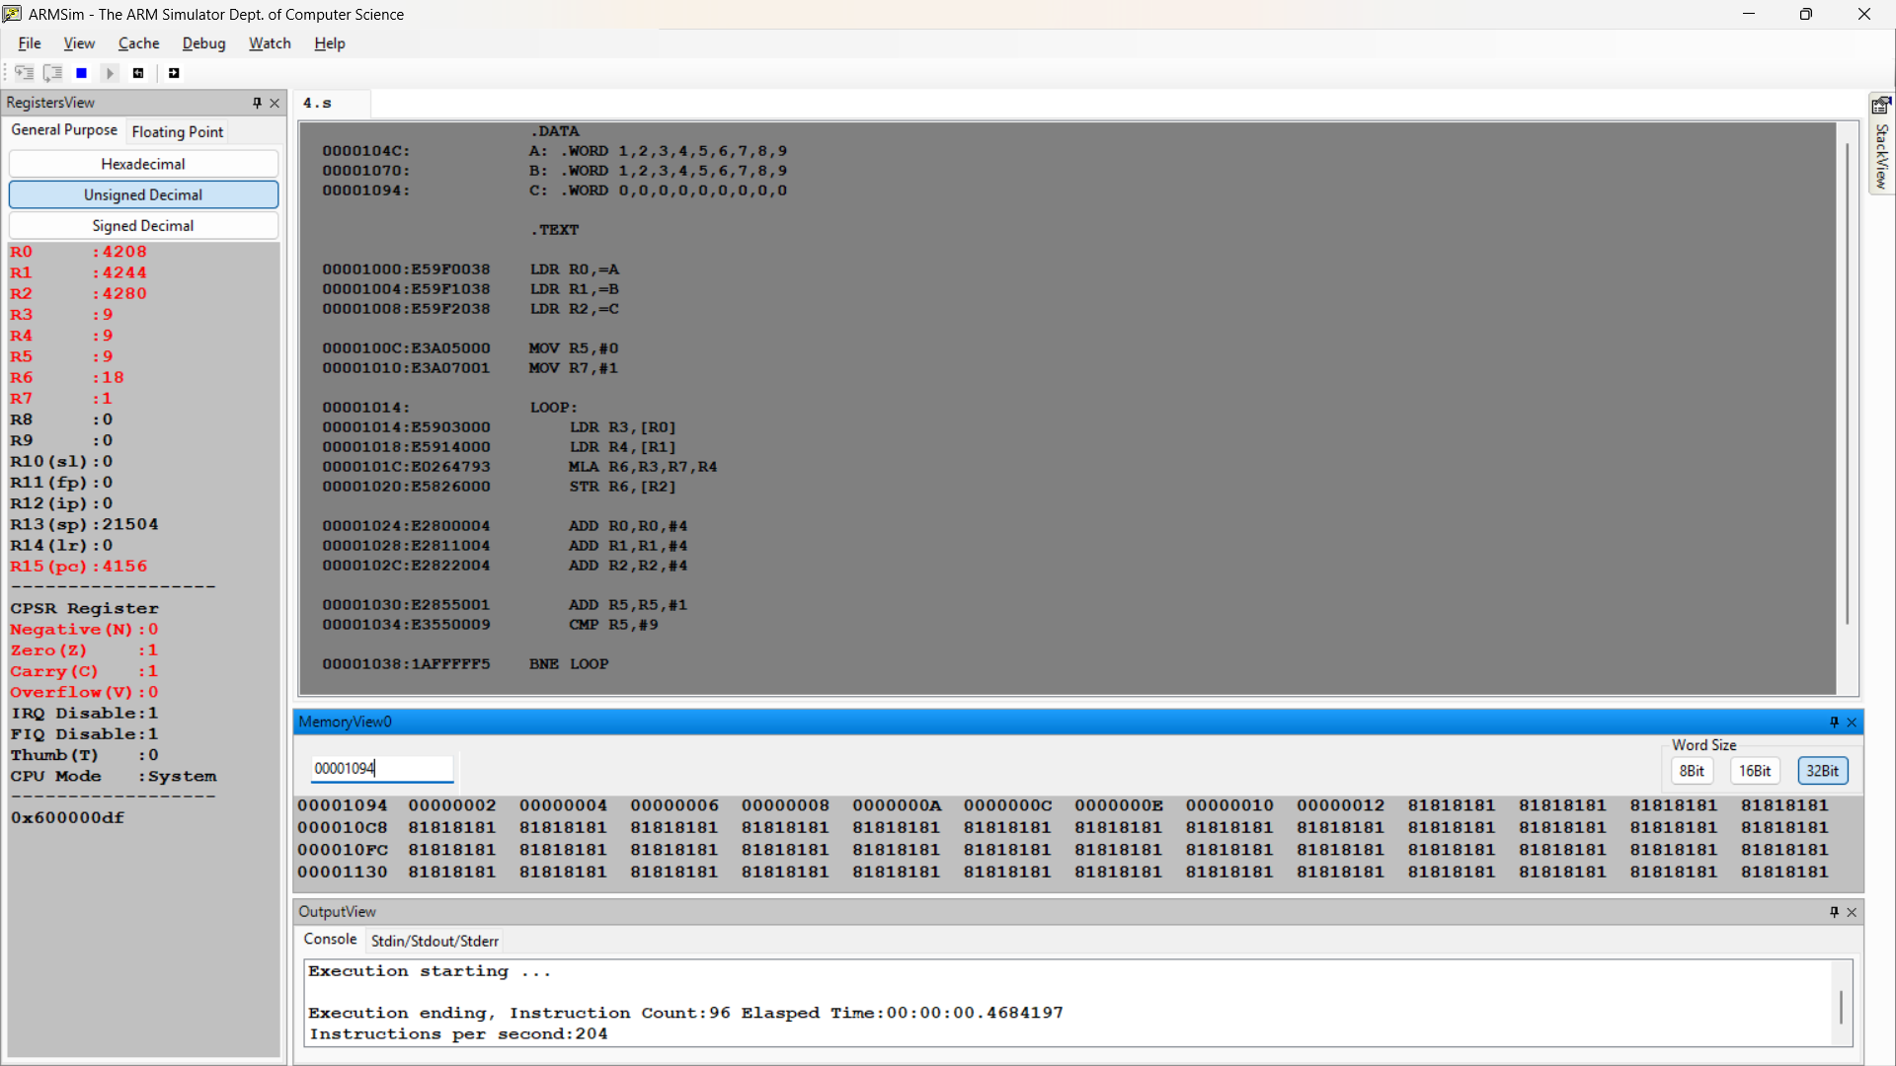

Microprocessor and Computer Architecture
UE22CS251B
4th Semester, Academic Year 2023-24
Date:
Name: Harshit Chandak | SRN:  PES2UG24CS185 | Section  C

LAB #____4_______ Assignment Question 1
Title of the Program
Write an ARM7TDMI ALP to check whether a given 32-bit number has odd or even parity (number of 1s).
It stores 00 in R7 if parity is EVEN and 01 in R7 if parity is ODD

- ARM Assembly Code
- Output Screen Shots
(Two Screenshot for each case including Register Window,Memory Window and Code Window)
.DATA
NUM: .WORD 4
PARITY: .WORD 0

.TEXT

LDR R0,=NUM
LDR R1,[R0]
LDR R7,=PARITY
MOV R8,#00
MOV R9,#01

MOV R2,#0
MOV R3,#0

LOOP:
TST R1,#1
ADDNE R2,R2,#1
MOV R1,R1,LSR #1
ADD R3,R3,#1
CMP R3,#32
BNE LOOP

TST R2,#1
STRNE R9,[R7]
STREQ R8,[R7]

.END

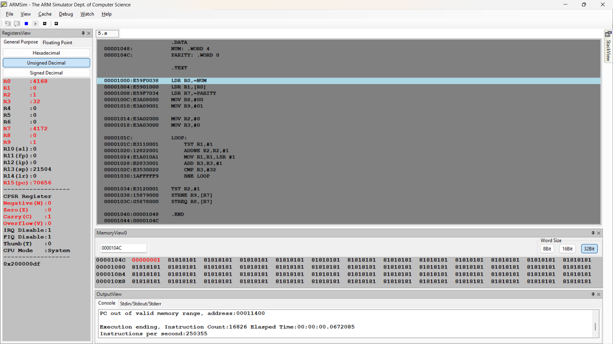

Microprocessor and Computer Architecture
UE22CS251B
4th Semester, Academic Year 2023-24
Date:
Name: Harshit Chandak | SRN:  PES2UG24CS185 | Section  C

LAB #____3_______
Assignment Question 2
Title of the Program
Write an ALP to perform Convolution using MUL instruction (Addition of multiplication of respective numbers of loc A and loc B)
- ARM Assembly Code
- Output Screen Shots
(One Screenshot including Register Window,Memory Window and Code Window)
.DATA
A: .WORD 10,20,30,40,50
B: .WORD 10,20,30,40,50

.TEXT

LDR R0,=A
LDR R1,=B
MOV R2,#0
MOV R5,#0
MOV R6,#0

LOOP:
LDR R3,[R0],#4
LDR R4,[R1],#4
MUL R5,R3,R4
ADD R6,R6,R5
ADD R2,R2,#1
CMP R2,#5
BNE LOOP

SWI 0x11

.END

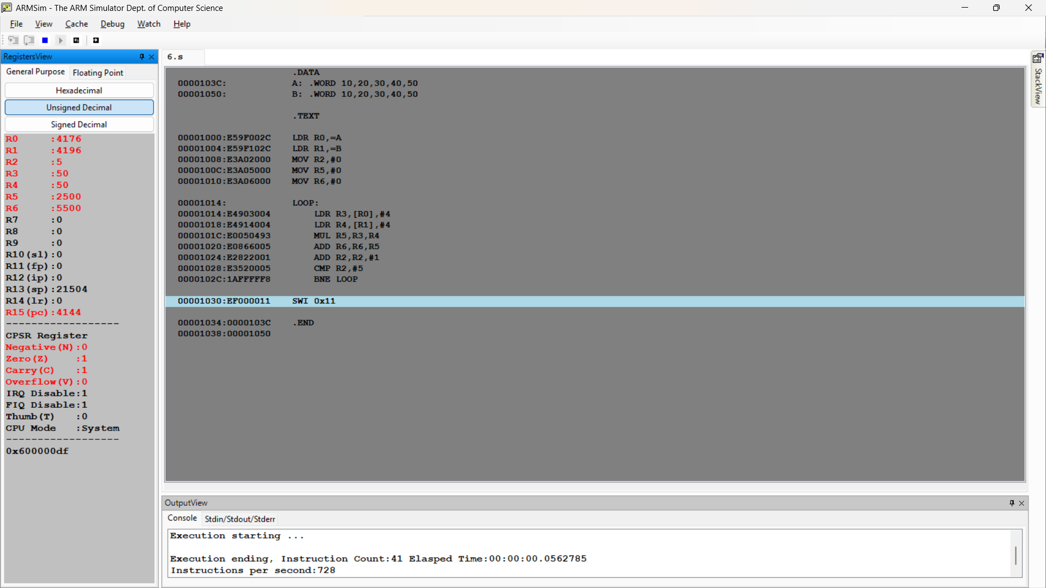

Disclaimer:
- The programs and output submitted is duly written, verified and executed by me.
- I have not copied from any of my peers nor from the external resource such as internet.
- If found plagiarized, I will abide with the disciplinary action of the University.

Signature:
Name:
SRN:
Section:
Date:

